EXPERIMENT NO. 4
Aim:
To develop RESTful APIs using Spring Boot and MongoDB for performing CRUD operations on car inventory data.
Theory:
REST APIs allow communication between the frontend and backend using HTTP methods such as GET, POST, PUT, and DELETE. Spring Boot is used to create the REST API, while Spring Data MongoDB connects the application with MongoDB for storing car documents. Postman is used to test the API operations, validation, and responses.
OUTPUT:

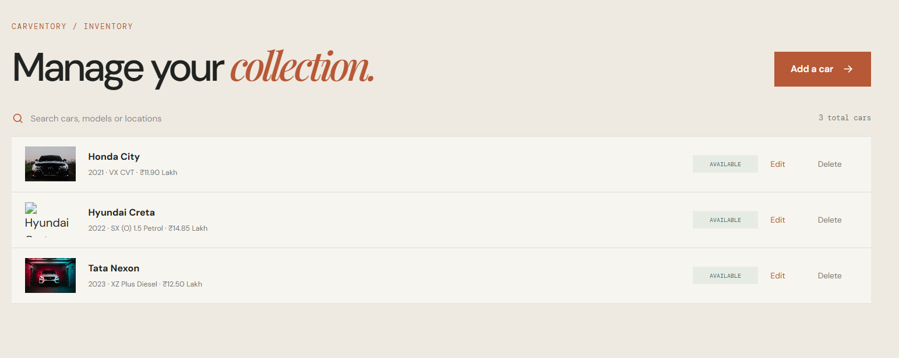
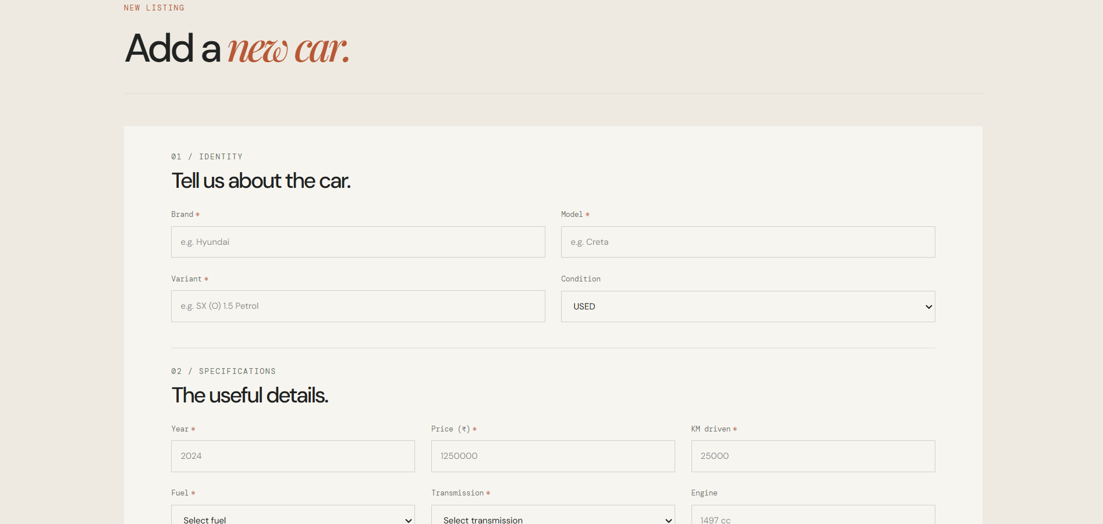
Main.jsx
import { StrictMode } from 'react'
import { createRoot } from 'react-dom/client'
import { BrowserRouter } from 'react-router-dom'
import App from './App'
import './index.css'
import { AuthProvider } from './context/AuthContext'
import { CarProvider } from './context/CarContext'
import { FavouritesProvider } from './context/FavouritesContext'
import { CompareProvider } from './context/CompareContext'

createRoot(document.getElementById('root')).render(
<StrictMode>
<BrowserRouter>
<AuthProvider>
<CarProvider>
<FavouritesProvider>
<CompareProvider>
<App />
</CompareProvider>
</FavouritesProvider>
</CarProvider>
</AuthProvider>
</BrowserRouter>
</StrictMode>,
)
POSTMAN:
GET – Retrieve All Cars
Fetches and displays all car records from the MongoDB database.
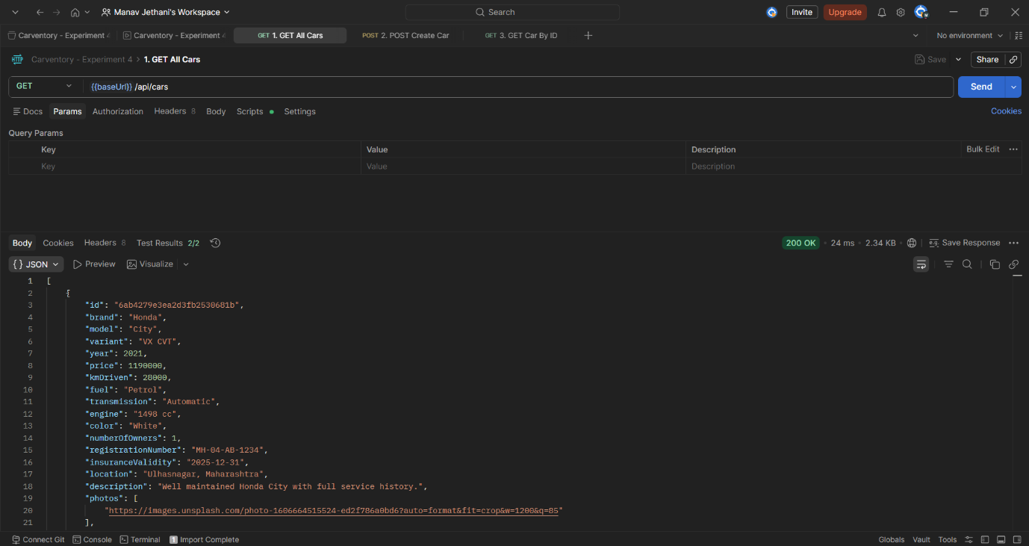
POST – Create New Car
Creates a new car record and stores it in the MongoDB database.
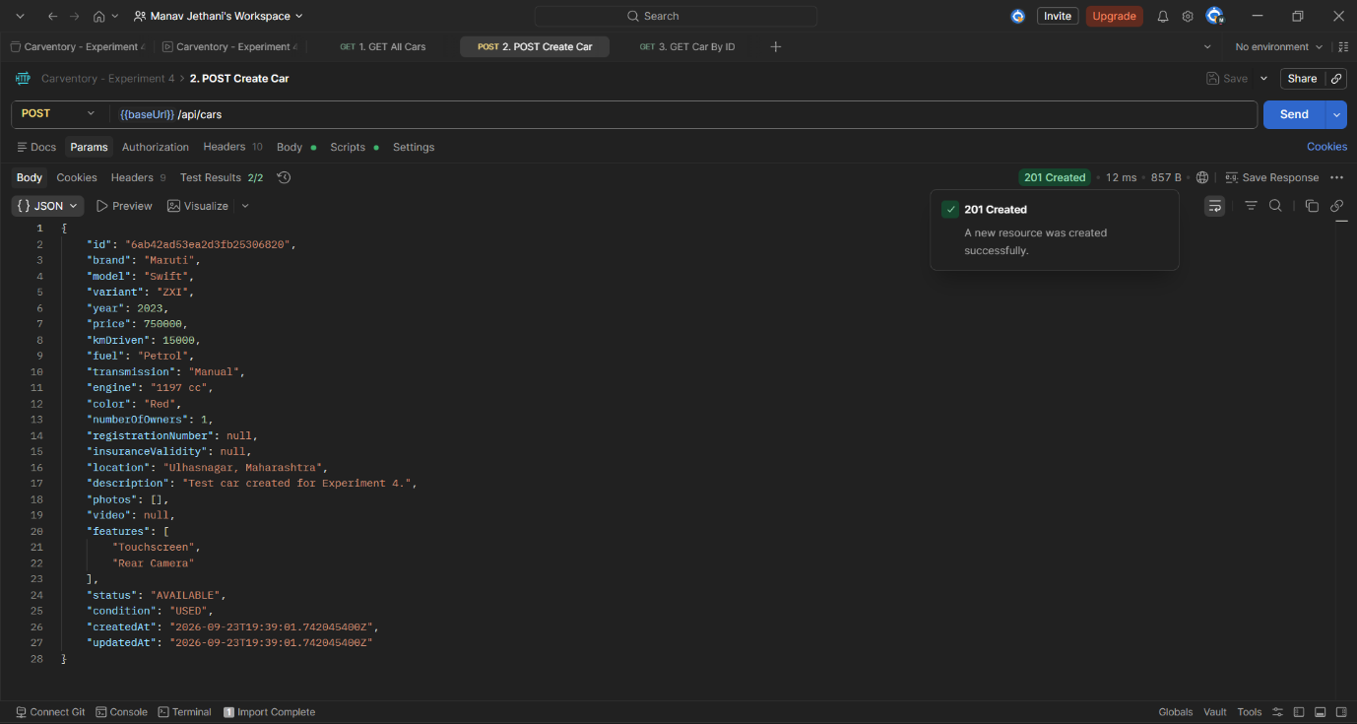
GET – Retrieve Car by ID
Retrieves a specific car record using its unique ID.
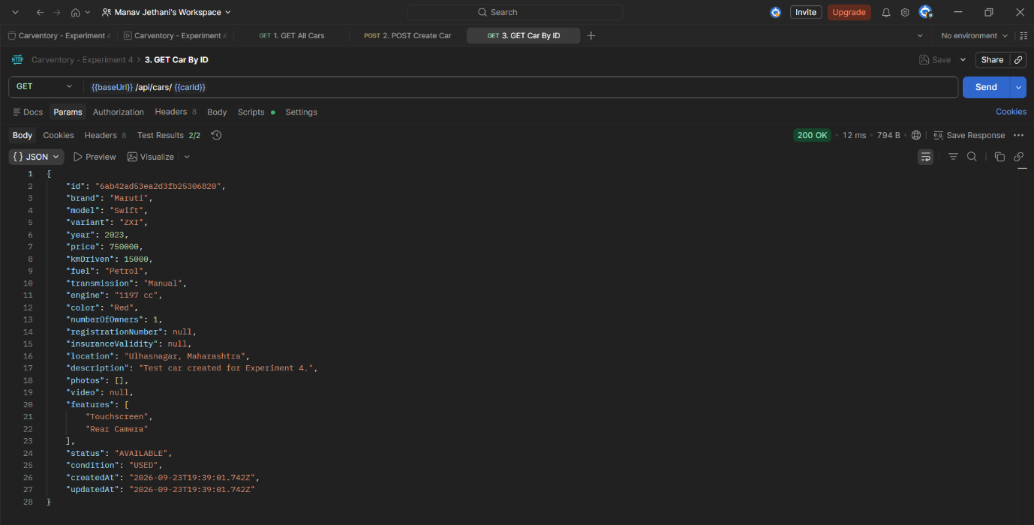
PUT – Update Car Details
Updates the details of an existing car record.
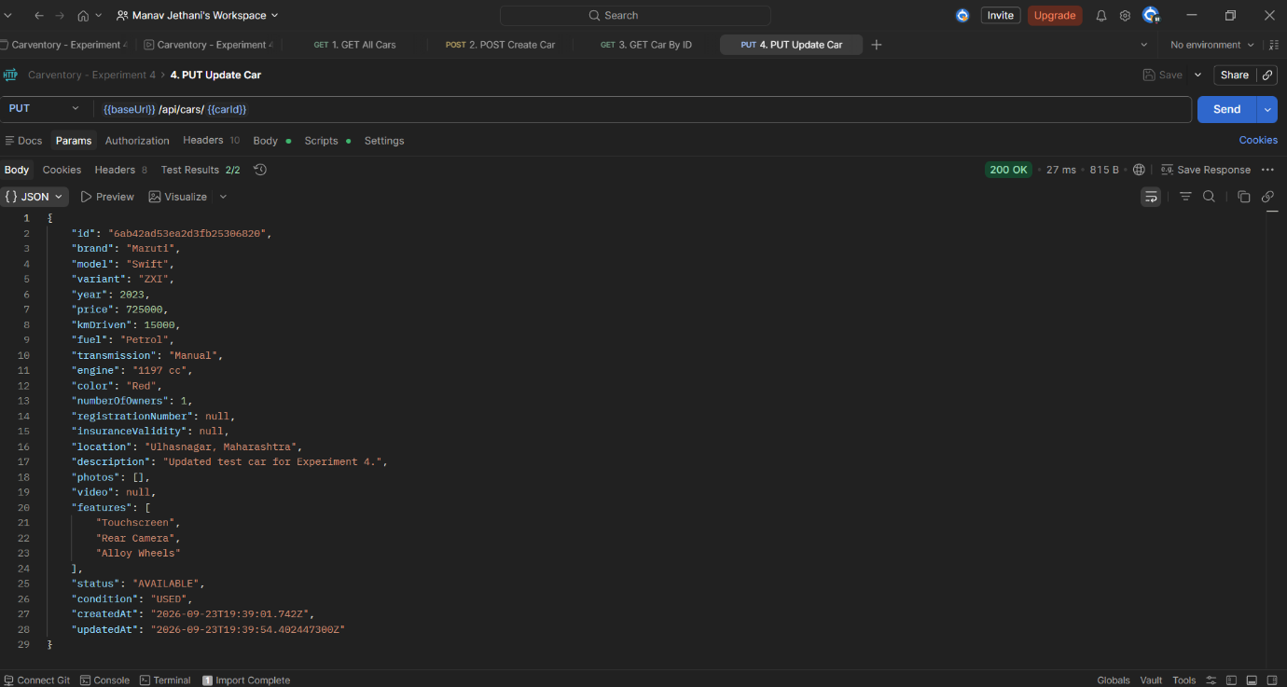
DELETE – Delete Car Record
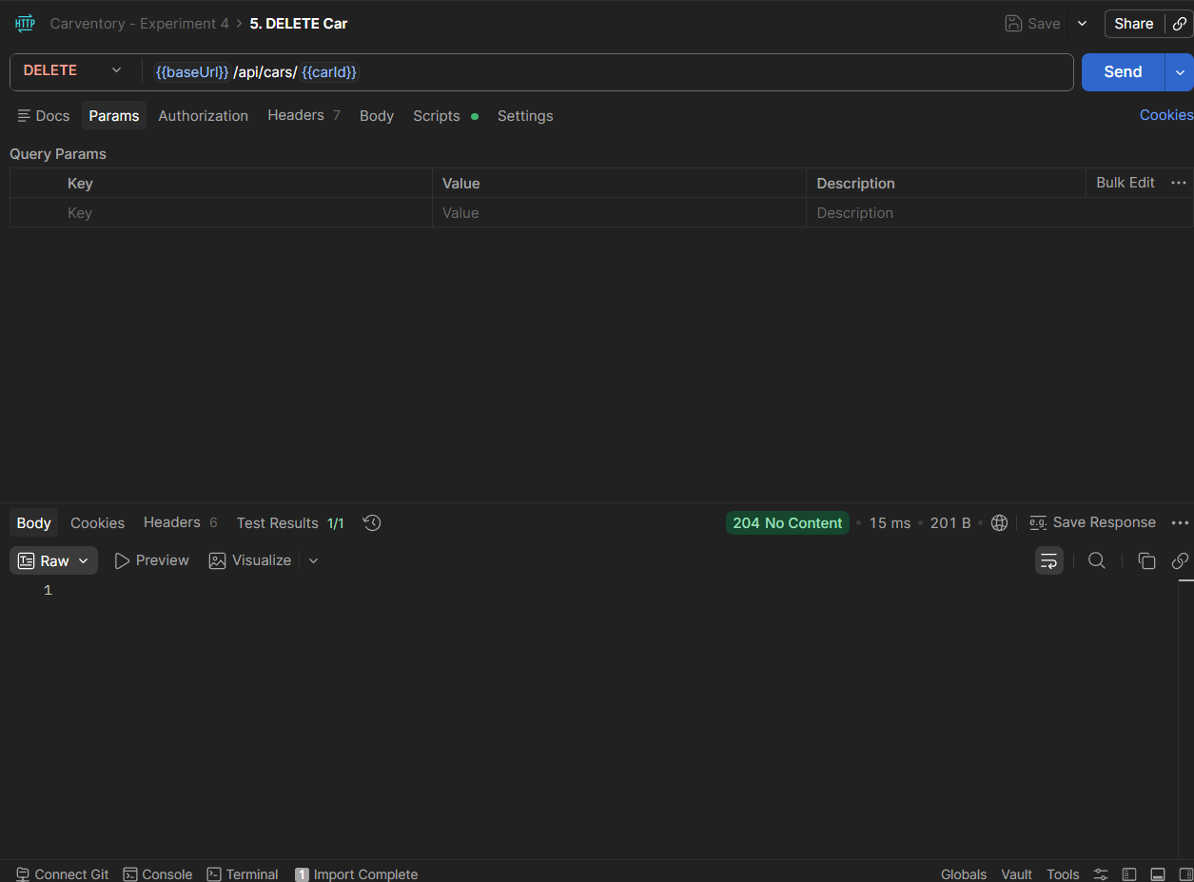
Conclusion:
The REST API was successfully developed and connected with MongoDB. CRUD operations, filtering, validation, and error handling were tested successfully using Postman, and the frontend was connected to the API for displaying and managing car data.
---XXX---

